**The Ark Documentation.**

**Add new subject.**

Log in and select your study.

Once you have chosen your study we will see the following functions. Click the Subject function in the top row.

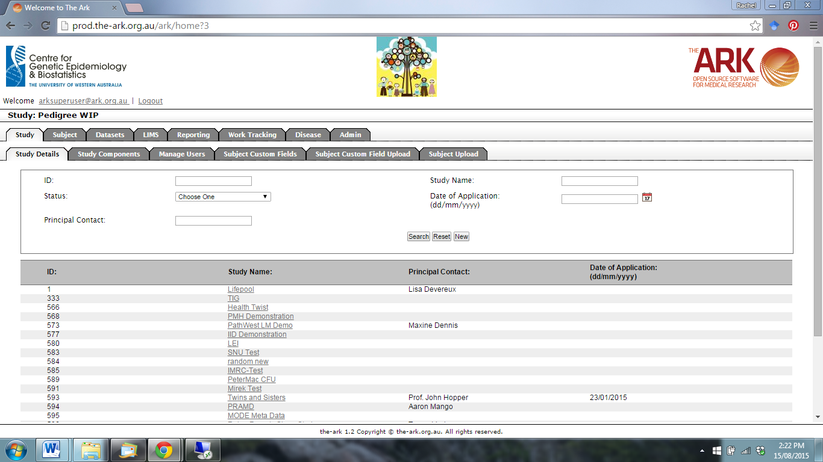

The following page will appear.

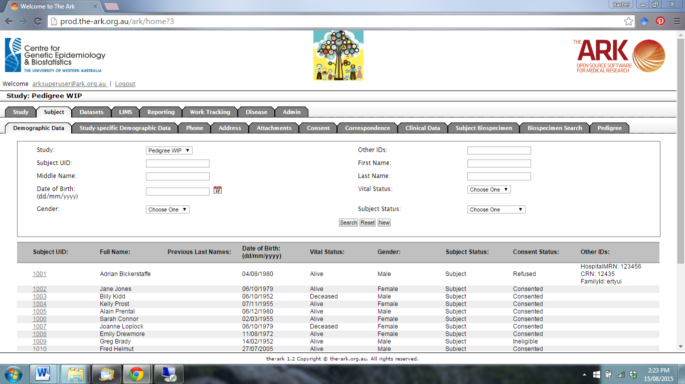

Click New.

The following page will appear.

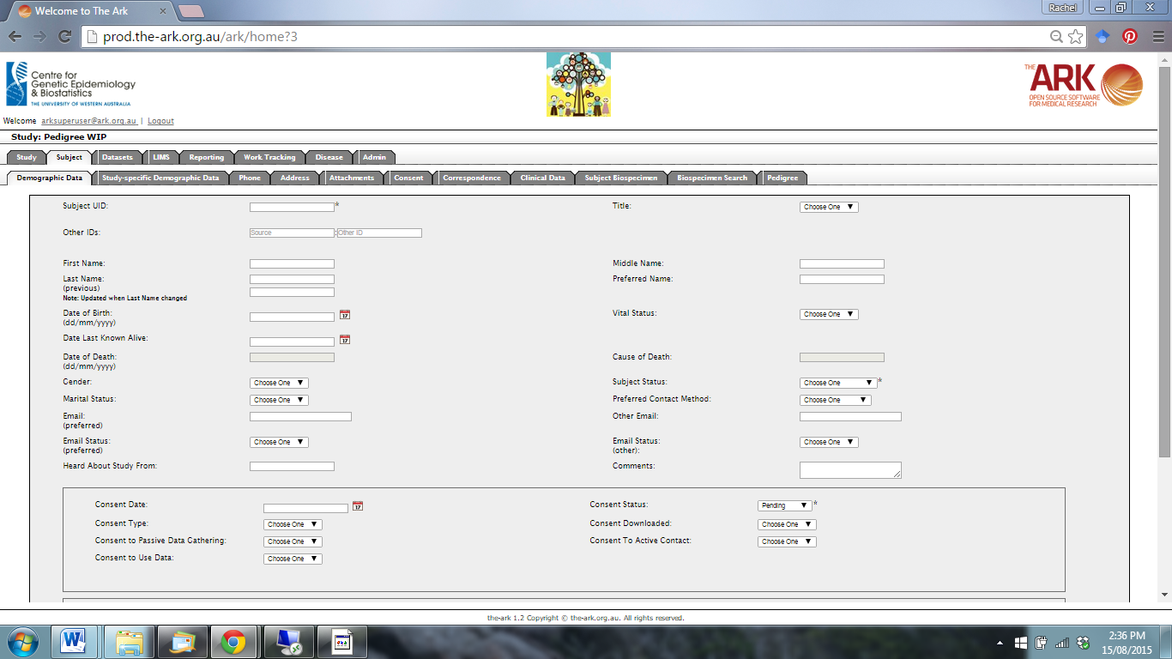

Enter the required Demographic Date fields for the new subject.

Use the drop-down menus and calendar functions to add subject information.

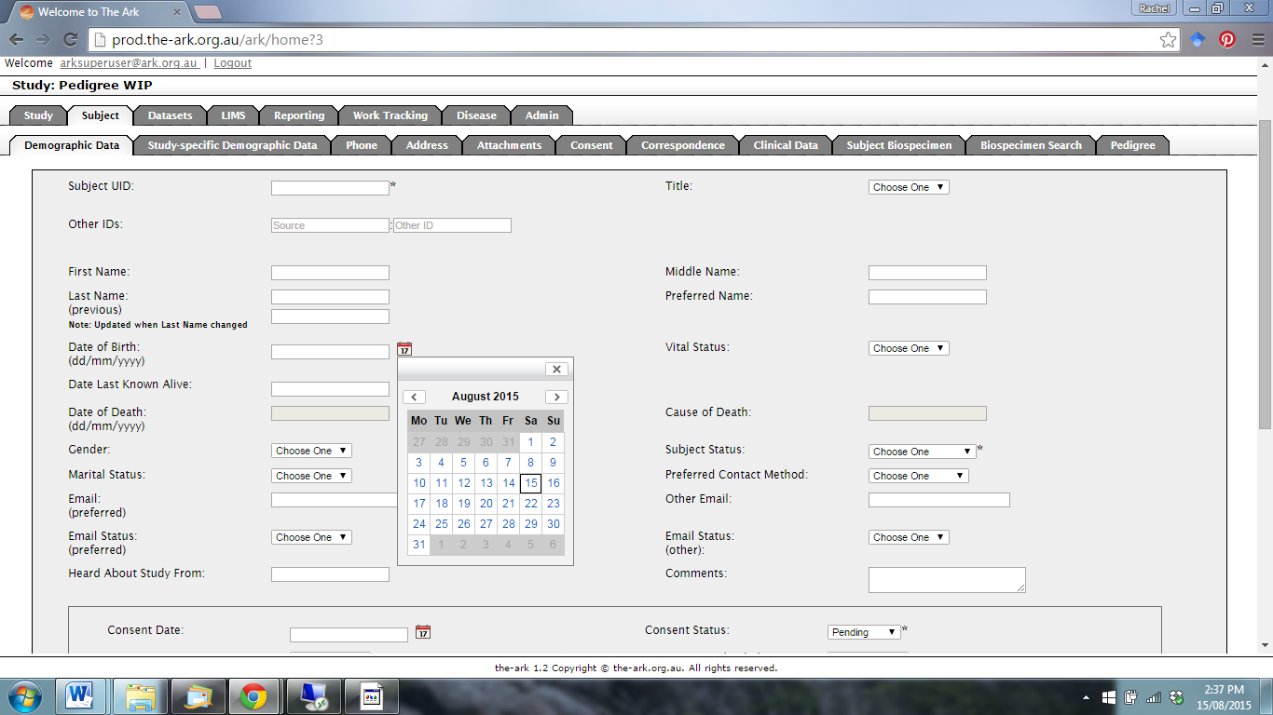

You can also assign the subject to additional sub-studies if required. Select the sub-study in the Available box and then click the right arrow to move to the Selected box.

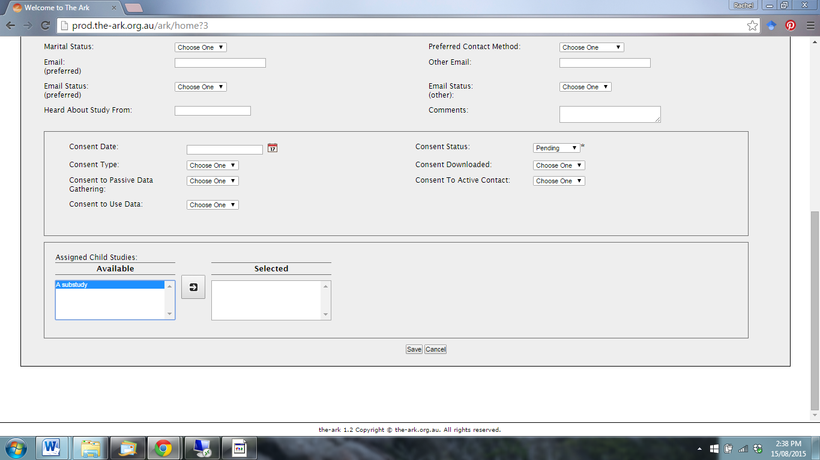

Once you have filled in all the required information for the new subject, click save at the bottom of the screen.

You should see the following confirmation message that the new subject has been created.

